St Swithun’s Road – Road Closure (Kirk Close – The Avenue junction)
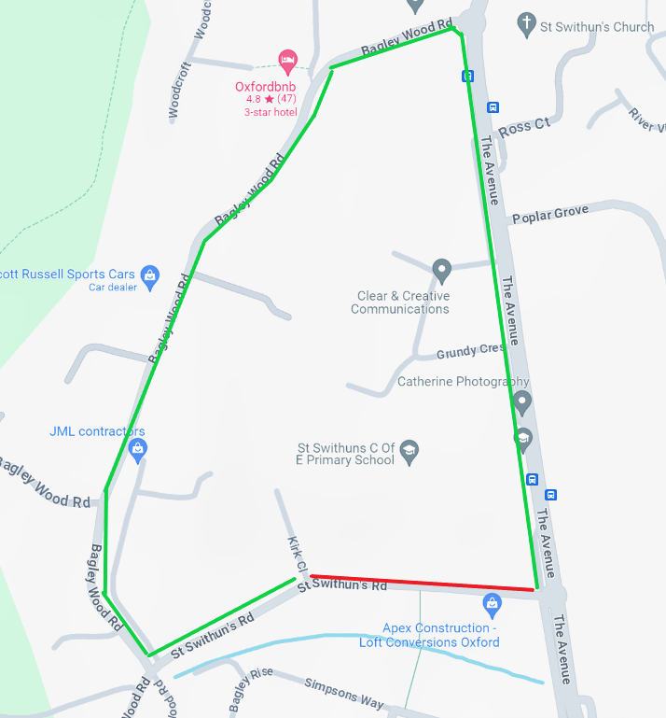

Diversion Route
St Swithun’s Road Bagley Wood Road The Avenue

