St Swithun’s Road – Road Closure (Kirk Close – The Avenue junction)
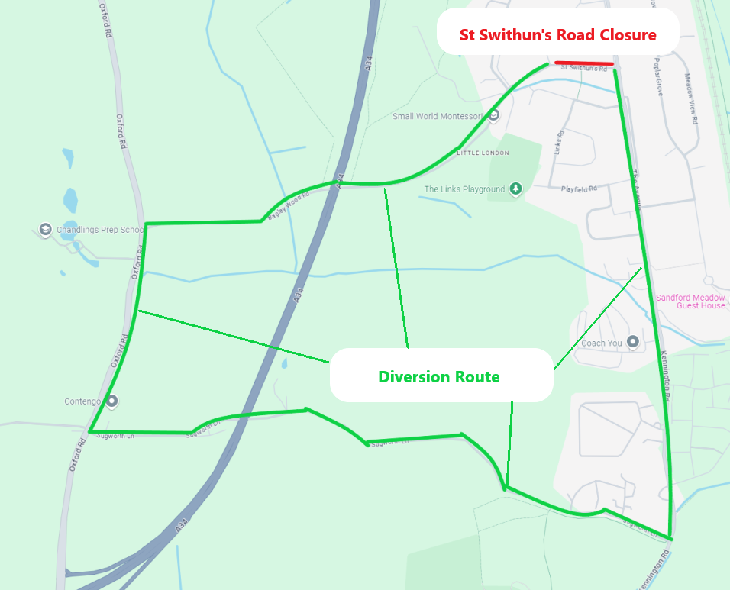
Diversion Route
St Swithun’s Road Bagley Wood Road Oxford Road Sugworth Lane Kennington Road The Avenue

